Parish Priest: Fr. Mark Croker  Phone:02-8331 7609 Presbytery  Mobile: 0428 190 759  Wednesdays- Fr. is at Bombala Parish  Mass: 9.30am & Delegate 2nd Wed 10.30am  Parish Secretary:  Mrs Sharon Nesbitt 02 8331 7608  Office Opening Hours  Mon Wed Thu open hours 9am-1pm/  2-4.30pm  Email: snowymonaro@cg.org.au  www.cg,org.au/cooma  Sacramental Program  Phone: Fr Mark Croker  Email: cooma@cg.org.au  St Patrick's Parish School  Principal:  Mrs Frances Robertson  Cnr Murray & Vale Street, Cooma  Phone: 02 6452 1721  Fax: 02 64523974  http://stpatscooma.nsw.edu.au  www.facebook.com/stpatscatholicparishcooma  Parish Pastoral Council:  Darren 0429 904 291  www.cg,org.au/cooma  www.cg.org.au/Jindabyne  www.cg.org.au/Bombala | ST PATRICK’S PARISH FAMILY  Three Parishes Together  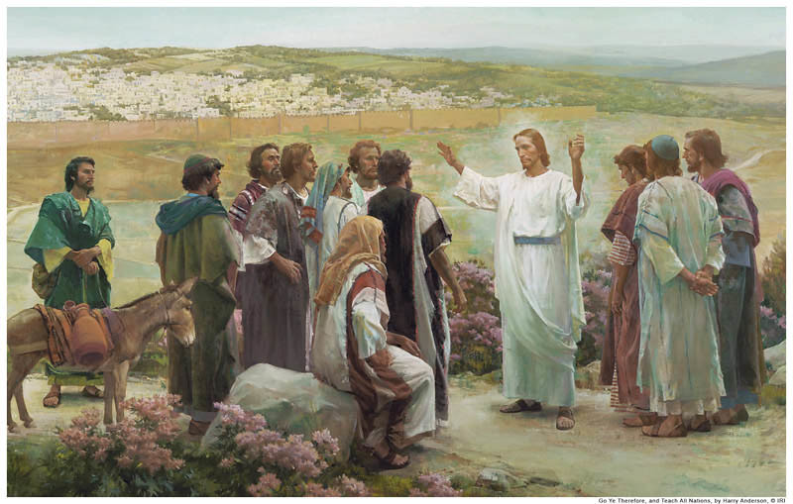  Baptism Request forms can be located on Parish website/at Parish Office, Fr Mark will be available to celebrate during mass on 2nd Sunday of the month | St Patrick’s Cooma Mass  Mass Sunday’s at 10am  Cooma Sacrament of Reconciliation  Thu 1st June 4pm  St Patrick’s Weekday  Mass: Tues, Thu, Fri 10am  Except Third Friday of Month Nursing Home Mass  9.30am Yallambee Lodge  11am Sir William Hudson  Adaminaby volunteer required-  Nimmitabel  Mass 3rd & 5th Sunday  *5pm Sat Vigil Mass  1st 2nd,4th Sun- LITURGY Sat 5pm  Numeralla  Mass 4th Sunday at 5.00pm  LITURGY 2nd Sunday 5.00pm  Berridale  Mass 2nd & 4th Sunday of month  Vigil Mass Saturday’s at 3.30pm  1st 3rd & 5th Sunday Liturgy  of the Word 10am Sunday  Jindabyne  2nd 3rd & 4th = Vigil Mass 5pm Sat  1st & 5th Sunday Liturgy 5pm Sat

Roster | 21st May | 28th May
Acolyte | Richard Cmunt | Kaitlyn Bosco
Usher | Kathleen Bashford | Terri Rick
Reader/Commentator | Joan Simpson Susan Tighe | Jo-Anne Brown Mike Introna
Altar Servers | Natalia & Amelia Zieja
Special Minister | Jan McLean | Therese Dawson
Children’s Liturgy | Belinda Wilkins | Kellie Summerville
Linen | Gaie Mooney | …………………..
Church Care 13th May | Jo-Anne Brown Jan Kelly Gaie Mooney | Barbara Menchin Marg Quodling
Hospital | Marg Quodling | Joan Simpson
Morning Tea | Joan Simpson | Roster to be prepared
FLOWERS:
Claire Neumeyer

Next weekend Readings
Pentecost Sunday /A
1st Reading Acts 2: 1-11
2nd Reading 1 Cor 12:3-7, 12-13
Gospel John 20: 19-23

We have an extra Devices TAP n Go is available in Church entrance for your donations. $15 each tap (Archdiocese split 70/30: 1st & 2^{nd JUST TAP!} The New Smart Device at door has the option to Choose your own contribution amount - swipe left to choose denomination options. Please request assist from Acolyte if required.

Please Pray for our Recently Deceased,
“We have loved them in life, let us not forget them in death”:
David Palmer; Don Povey; Brian Kaufline; Arthur Johnson, Adella Mikulandra.
Anniversaries & Special Intentions: “In loving memory of” Kevin Lette
Prayers for our Sick: “May they be comforted through the Spirit of healing.
Jara Gregor, Margaret Kellond

Morning Tea 10am Mass this week . Thank you to Joan Simpson.
We would like to resume a Parish morning tea roster, if you would be available assist on roster basis to enjoy a cup of tea or coffee after Mass we would love to hear from you, please talk with Joan Simpson or Fr Mark to advise your availability or even occasional assistance would be great!
Project Compassion has been counted and transferred to the Caritas Australia , we have been able to provide your combined Parish donation of $2,518.43, thank you for your support, Fr Mark.

St Vincent de Paul Winter Appeal will be held next Sunday 28th May 2023. Please take an envelope found on the pews and return it next week for annual winter appeal.
A collection will be taken at the Church Doors after Mass on Sunday 28th May.
Kindly consider donating to this very worthy charity, to help provide much needed support to those in our local Communities.

Our Parish Office will not be attended this Thurday 25th May, to attend Deanery meeting in Canberra.

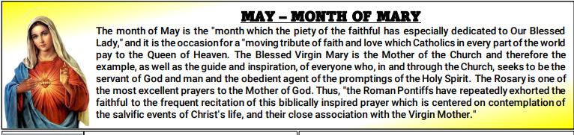

Joke:

Paddy and Mick are walking down the road and Paddy has a bag of donuts in his hand.
Paddy says to Mick: “If you can guess how many doughnuts are in my bag,
you can have them both.”

